How to process a budget query:
Click on the Budget Queries in the Menu

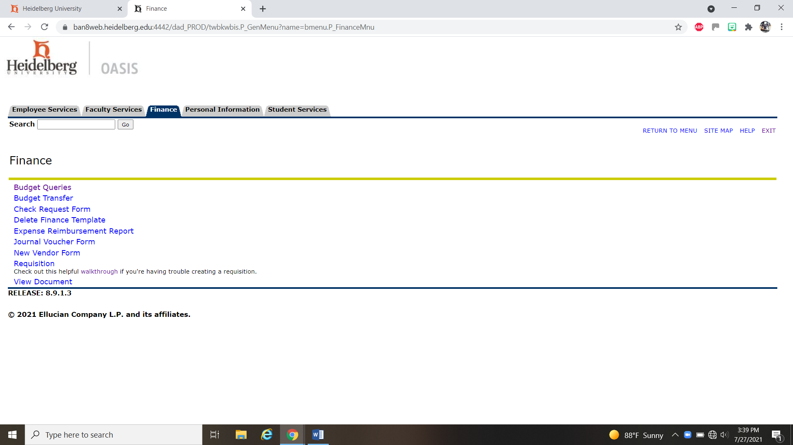

Create a new query type should be: Budget status by Account and then click Create Query

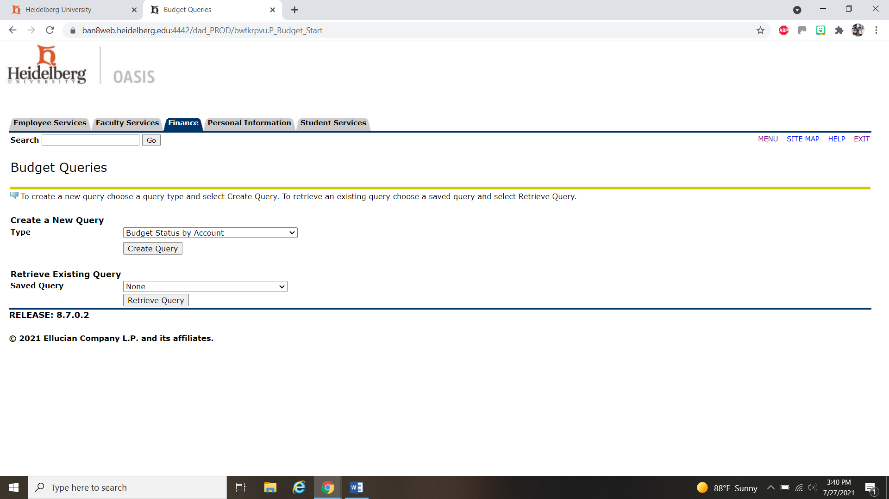

These boxes should be checked. DO NOT SAVE THIS QUERY…yet

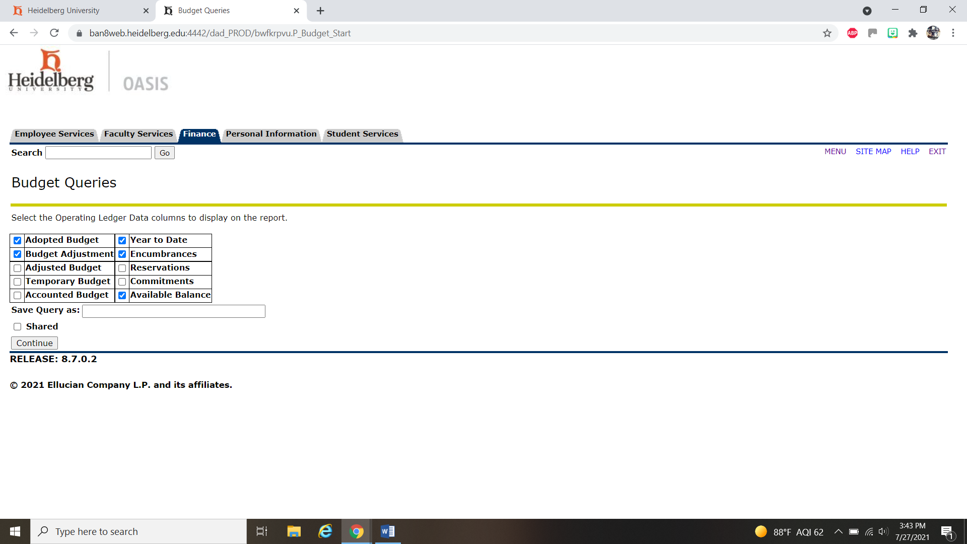

Make sure you have your account number (Fund, Org & Program) and make sure you have the correct fiscal year and check the box to Include Revenue Accounts. DO NOT CLICK THE SHARED box as that shares it with everyone. Click Submit Query.

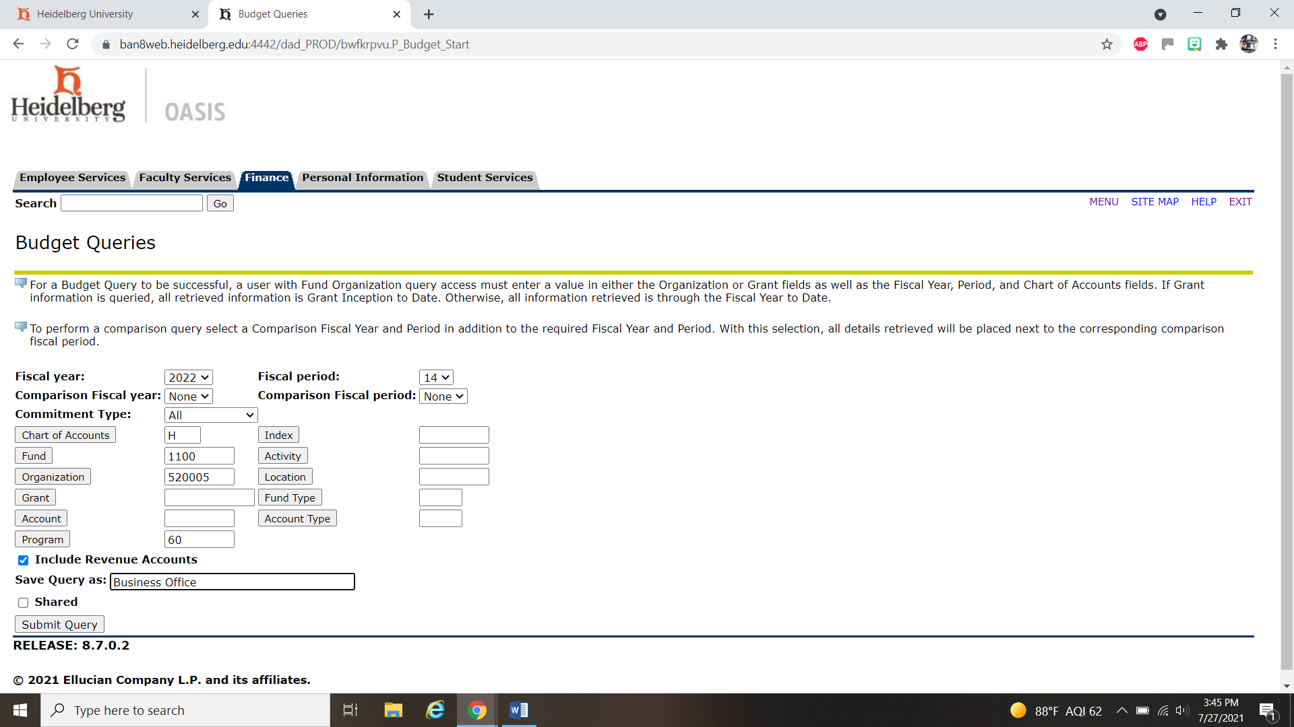

This is where you will see your budget and your activity along with your available balance.

