How to Process a Budget Transfer:
Click on Budget Transfer in the Menu.
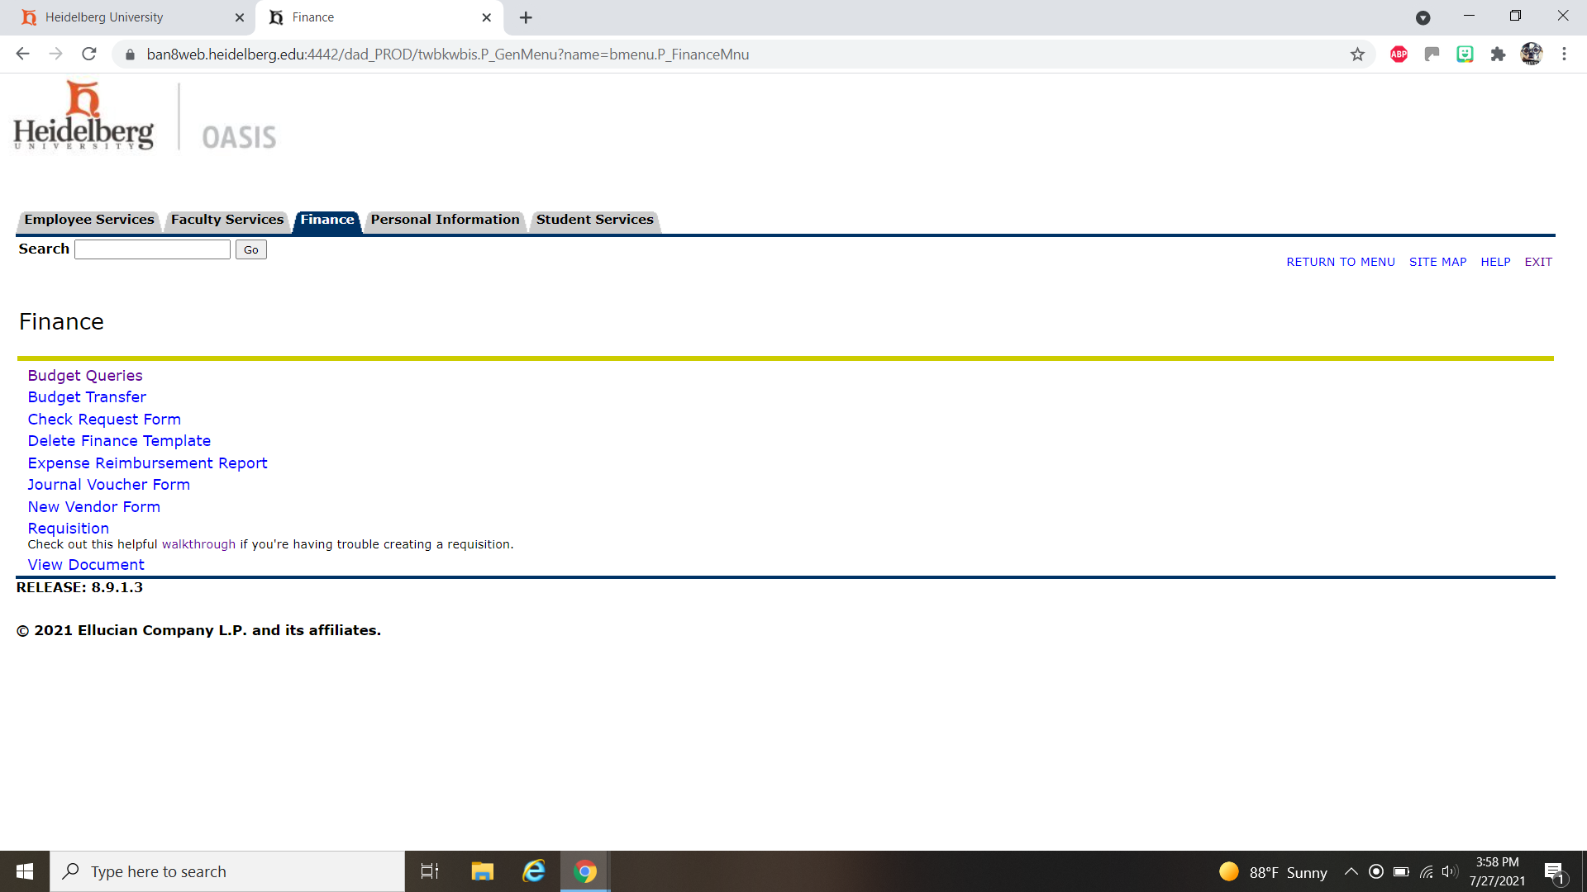

You can leave the transaction date to the current date unless you need to put it in the previous fiscal year. Then, you will need to put in 6/30/20xx. Next, you will put the total of your transfer in the Document Amount box. (If you want to move $5 from supplies and put $5 in travel the total document will be $10).

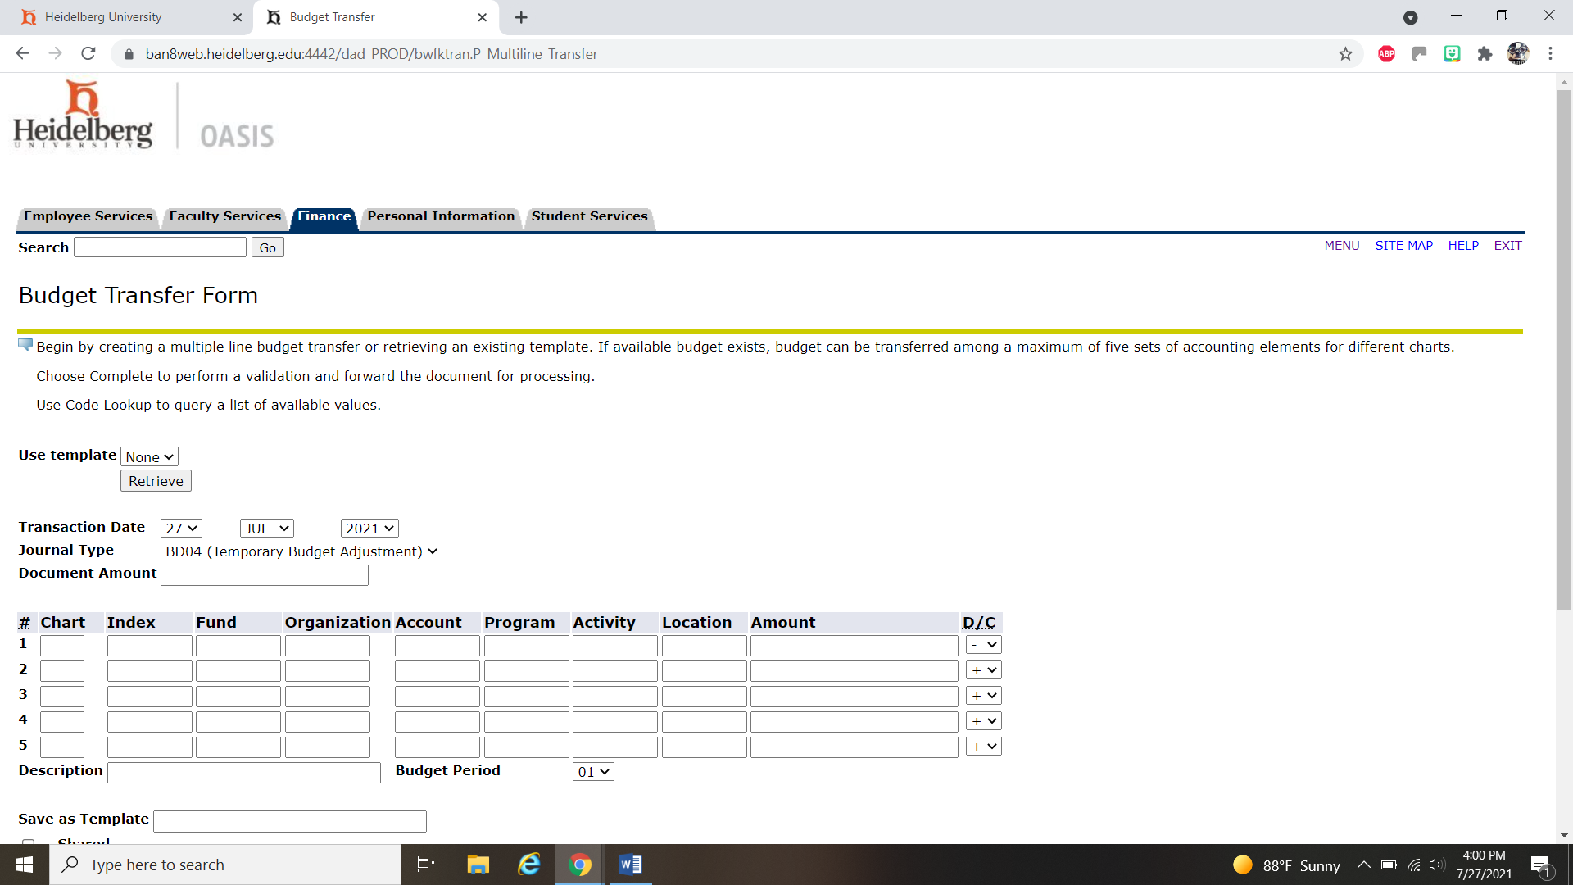

Your screen should look like this with it completed. Make sure you click the Complete button and you should receive a “J” number.
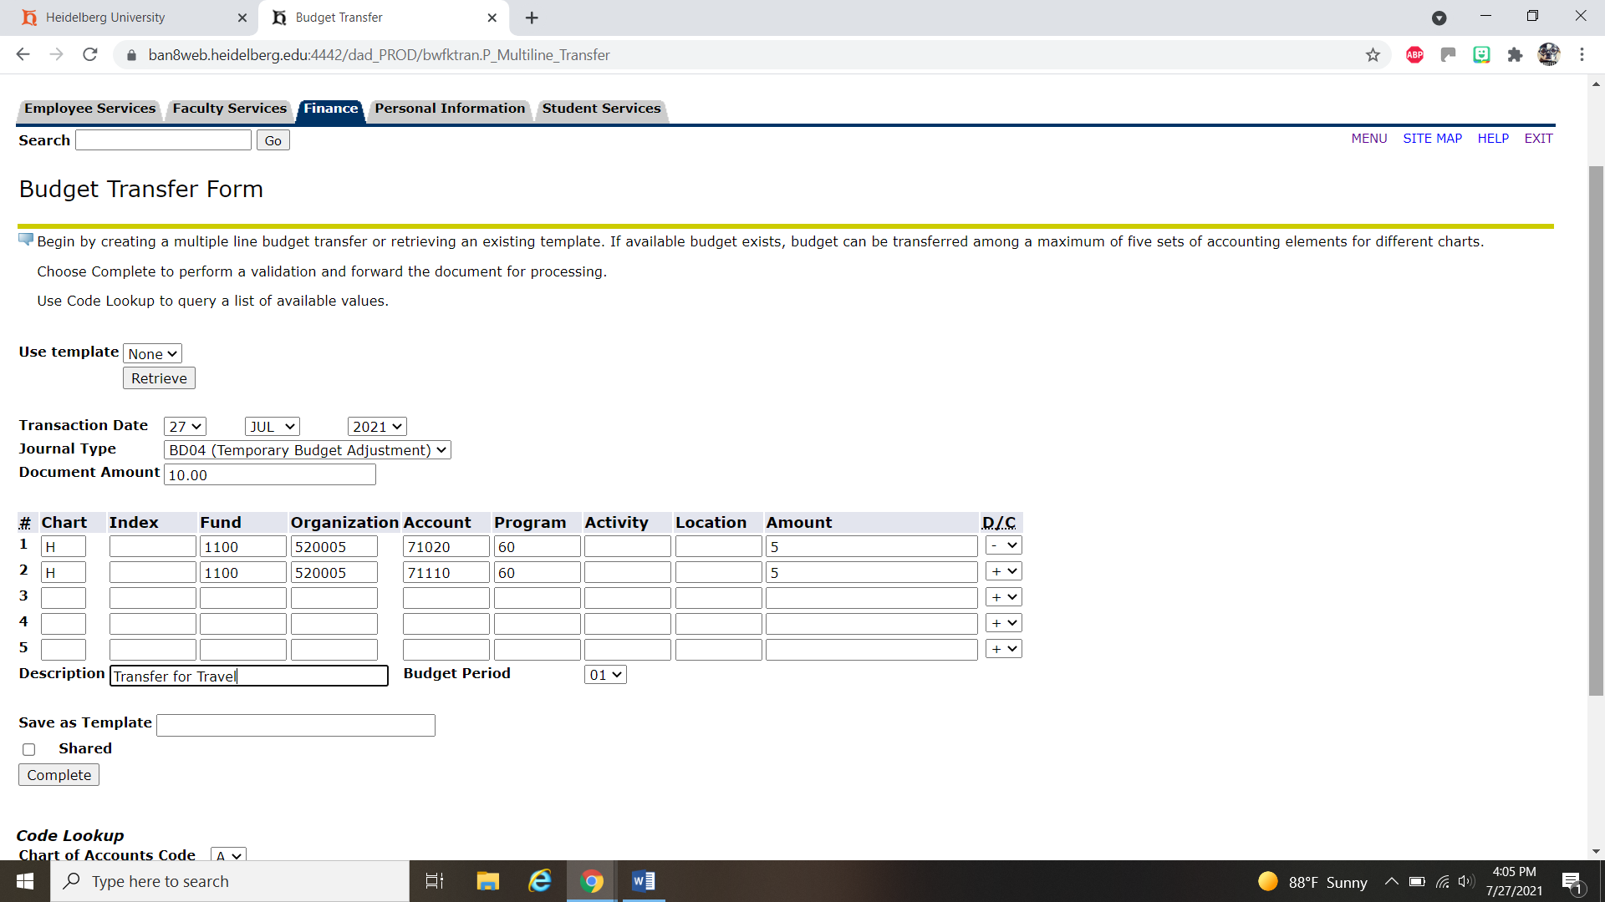

See below for the example of the J number as it is then forwarded to the Business Office.
