How to Process a Requisition/Purchase Order:
Before you click on the Requisition check out the Walk-Through PDF as your guide.
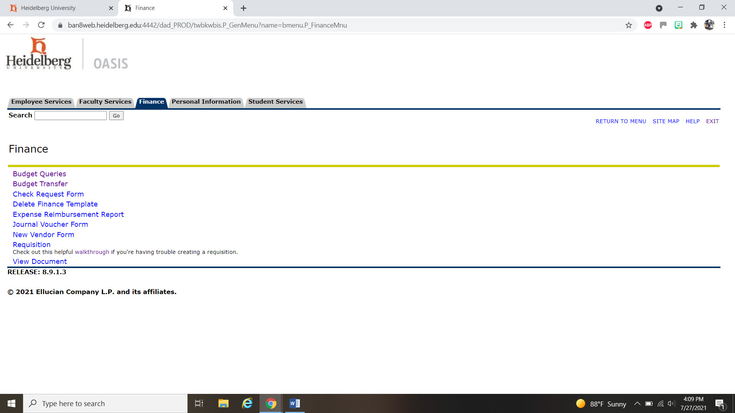

This walkthrough gives you the step by step on processing your requisition.

