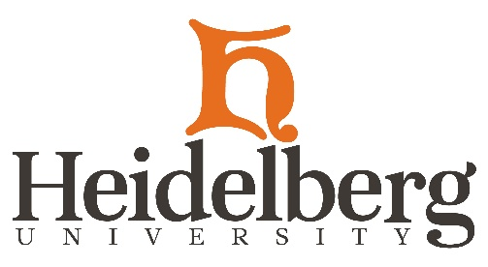

Sunday, March 15, 2020
Dear Heidelberg Community,
Earlier today, Governor Mike DeWine announced the indefinite closing of all bars and dine-in restaurants as the next step to slow the spread of the COVID-19 coronavirus. Restaurants will still be allowed to stay open for carry-out and delivery.
In keeping with the governor’s directive, Parkhurst Dining has suspended continuous dining at Hoernemann Refectory, effective Monday, March 16, 2020. We are taking this measure to ensure the safety of our entire community. Although Hoernemann Refectory will be closed for regular dining, Parkhurst and staff will provide quality food safely and consistently. Students who return to campus from Spring Break will be provided take-out meals available during breakfast, lunch and dinner hours. Students will be able to choose their meals to go.
Hoernemann Refectory hours are as follows:
BREAKFAST: 8 a.m.-9 a.m.
LUNCH: 11 a.m.-1:30 p.m.
DINNER: 4:30 p.m.-7 p.m.
The Heidelbean!, Berg Bistro 1850 and the Saurwein Power Station are temporarily closed.
The University and Parkhurst Dining are aligned and unified in our commitment to serve and support all of our students in this challenging and evolving time of the COVID-19 coronavirus threat to our community and our society.
Sincerely,
Rob Huntington
President
Chris Abrams
Dean of Student Affairs
Anthony Ippolito
General Manager
Parkhurst Dining
Rob Fehle
Executive Chef

