Setting up banking information on OASIS/TouchNet for the bank to verify

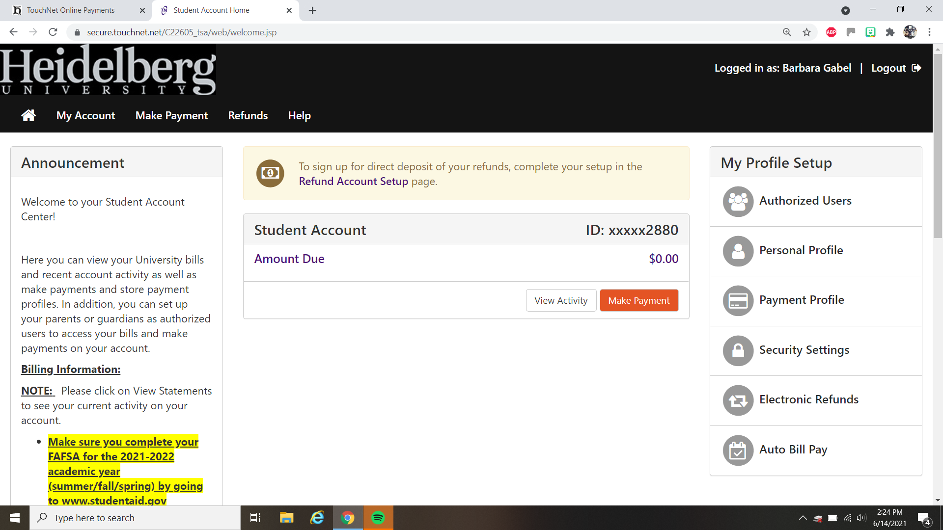
This is where the parents/students can set up their Bank accounts for the first time.

y

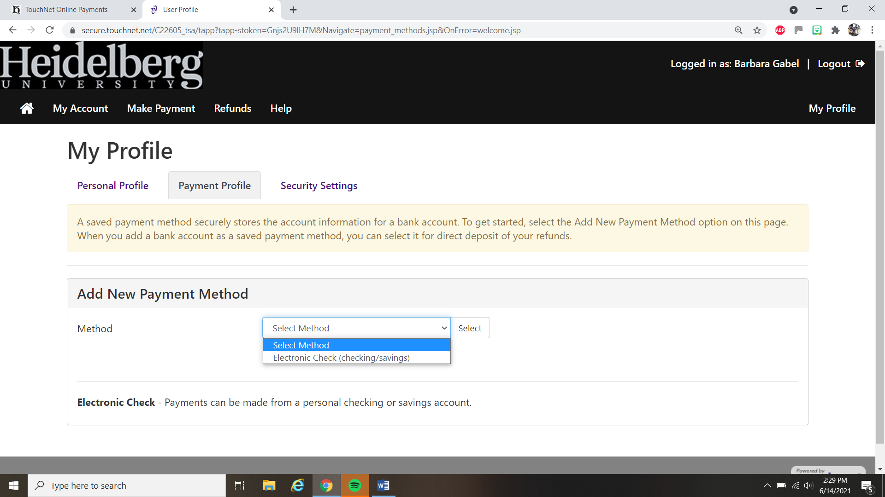
This is where they will just select Electronic Check to set up their banking information.

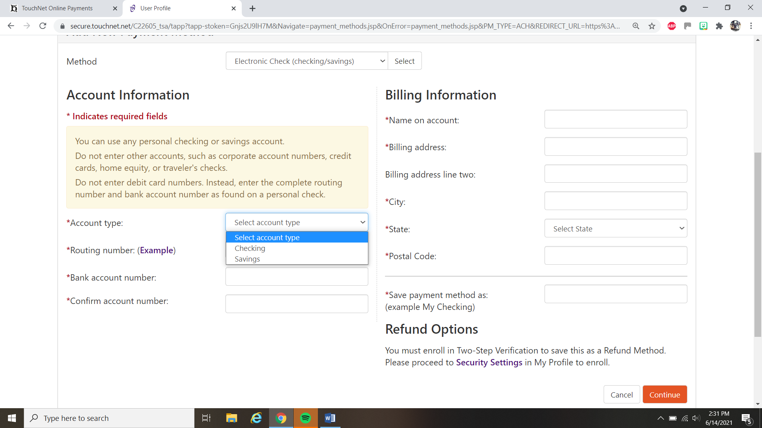

This is where they will actually put their banking information in and save it as whatever they wish to call it and then click continue.

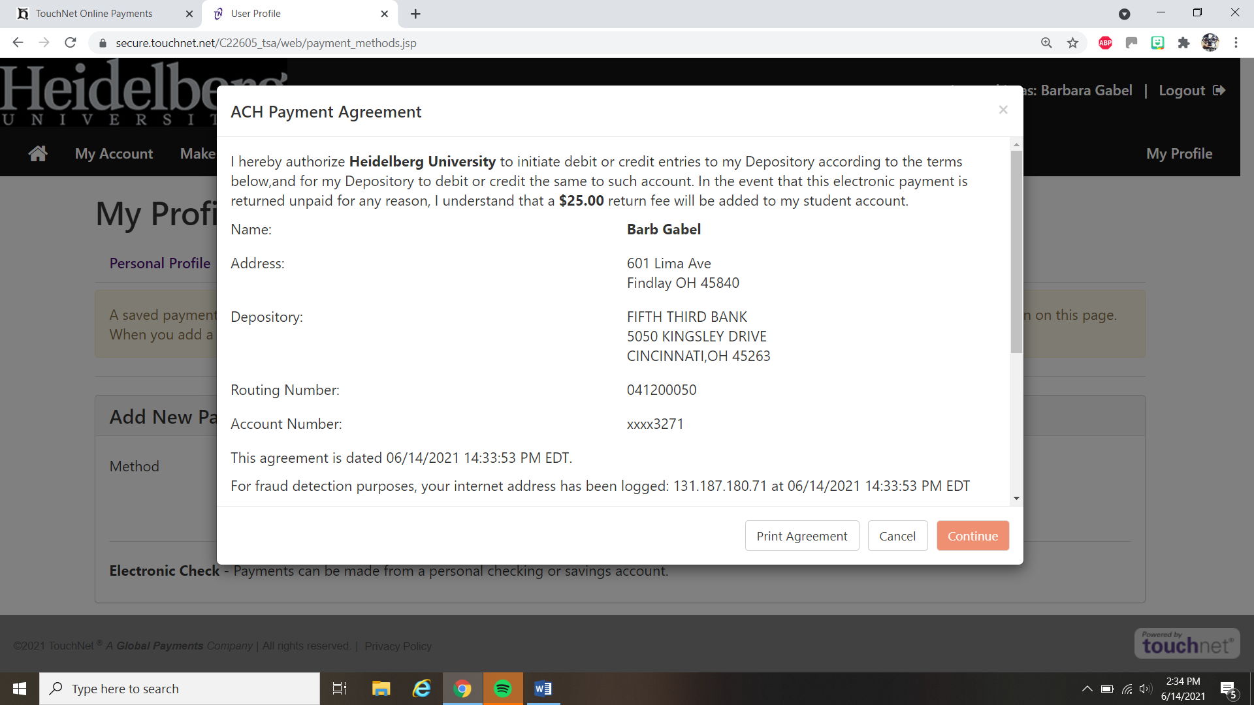

Then, they will receive an authorization page and they just need to scroll down and check the I Agree box and then hit continue. It shows what account they actually set up.

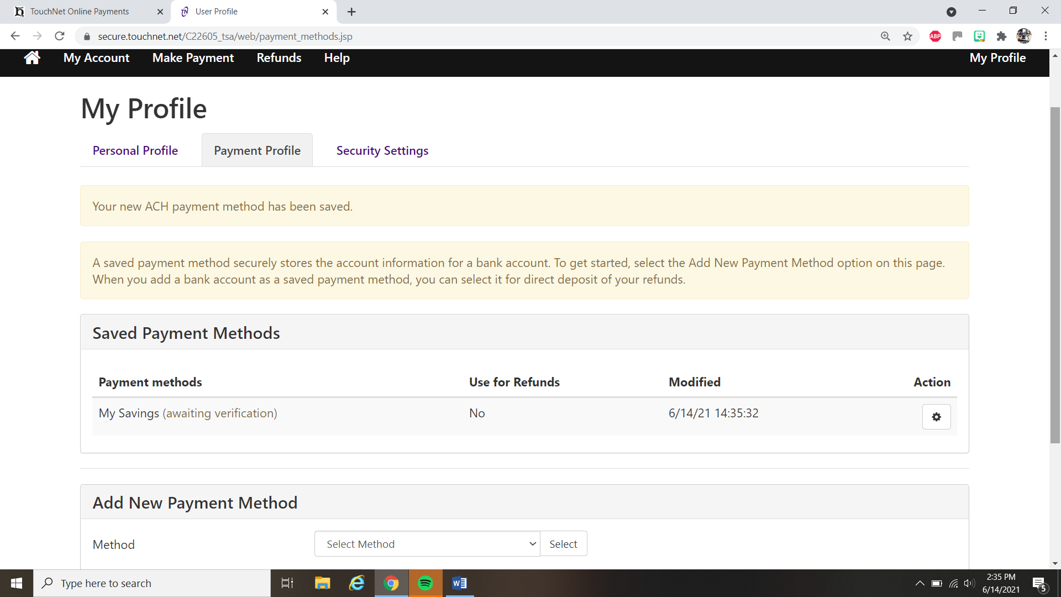

This is where they will see that their Payment Method is in “Awaiting Verification” stage. This is where it may take up to three (3) days for the bank to verify. Once it is verified, they should see that it changes to Verified and that payments and if they have the it used for Refunds ready to go.

